Careers, Employability and Skills
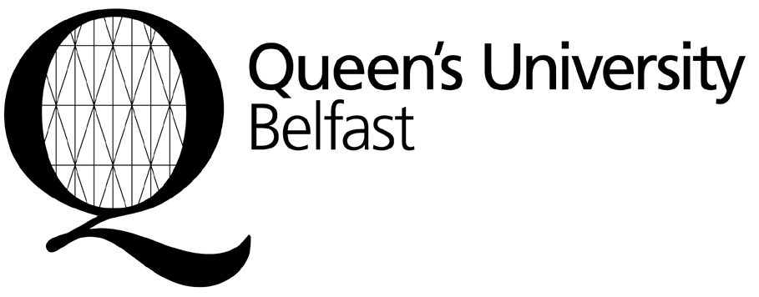

Belfast BT7 1NN
Northern Ireland
United Kingdom

Tel: +44-28-9097 5255
Email: erasmus@qub.ac.uk

Please complete and return to the Global Opportunities Team,
Careers, Employability and Skills at the end of your teaching visit

Confirmation of Erasmus Teaching Visit
(to be completed by Host institution)

This is to confirm that (name of teacher)

undertook an Erasmus teaching visit at this institution

in (subject)

for a period of days

from (date) to (date)

and undertook hours of teaching

at (institution full name and address)

Signature

Name

Position
(Head of Department or Erasmus Institutional Co-ordinator)

Date
Official HOST University stamp

